# User Interface Wireframes

### Login screen:

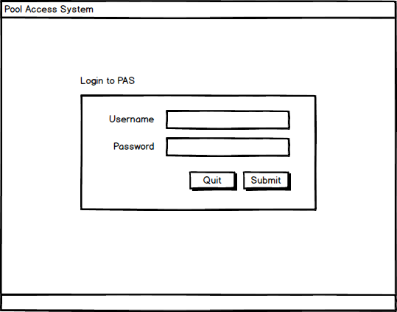

The Login Screen is used to verify users with username and password credentials. Successful verification will open the main program, defaulting to the Find Swimmer screen. Unsuccessful authentication will display an error message at the bottom of the screen

Instructions:

* Type username and password into the respective fields
* Click submit to authenticate username and password

### Find Swimmer screen:

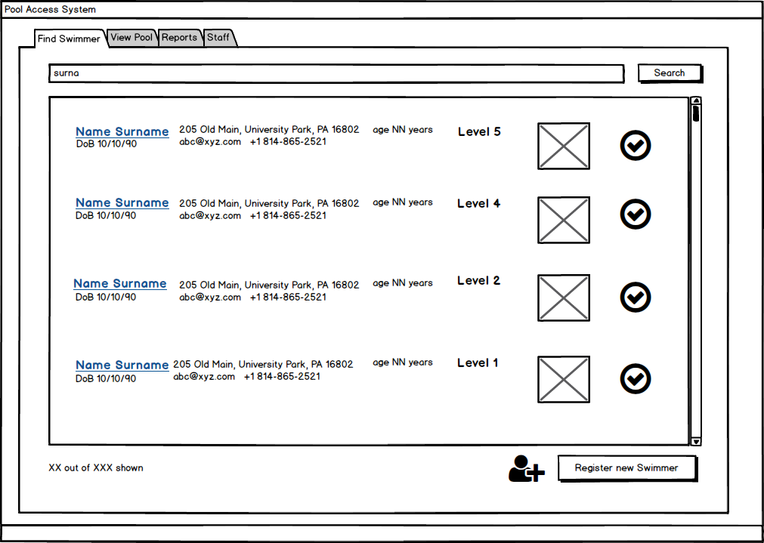

The Find Swimmer screen displays a list of all swimmers currently registered to the system along with their general information and picture. The user can refine the list by searching for the swimmer’s name or key words in the swimmer’s general information. If the user is a manger, they can edit the swimmer’s profile or register a new swimmer. The user can also check-in and check-out swimmers.

Instructions:

* Search by Name or Key Word
  + Type a name or key word as it would appear on the screen (i.e. phone numbers must be entered as XXX-XXX-XXXX) into the search field and click the search button. The screen will display matching results or an error message.
* Edit Profile
  + Click the ‘Edit’ button with in the row of the swimmer to be edited
* Check-In/Check-Out Swimmer
  + Click the check-in or check-out button within the row of the swimmer to be checked into or out of the pool. The buttons will alternate in active status to reflect whether a swimmer is in or out of the pool.
* View Full Profile
  + Clicking on the swimmer’s name will redirect the user to the swimmer’s profile, where they are able to view more detailed information and edit if permitted.
* Navigate to another use case
  + Click on the tab on the top of the screen that corresponds to the desired use case

### Register new Swimmer:

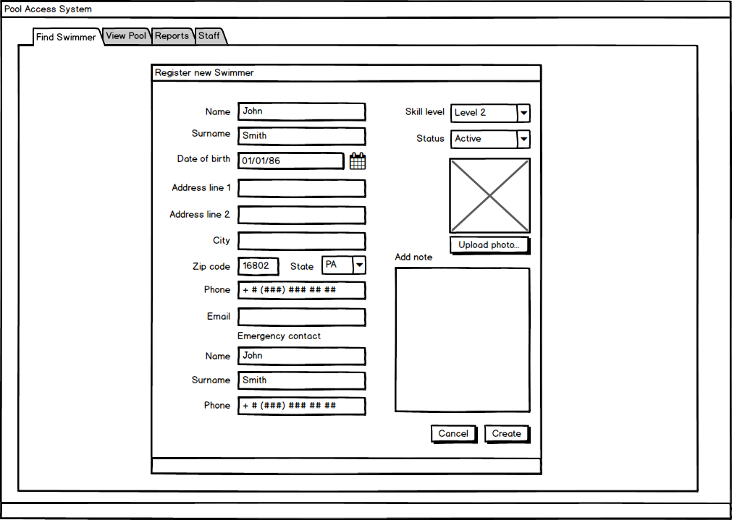

Register new swimmer allows the user to create an entirely new swimmer by filling out personally identifiable information which can later be used to search by in the “Find Swimmer” screen. The “skill level” dropdown corresponds to the swimmer’s swimming skill which relates to how much focus should be placed on this swimmer by the lifeguards. The Status dropdown refers to whether or not the swimmer is banned, suspended, or active in regards to accessing the pool. This defaults to Active, but can be changed depending on the situation.

* Upload photo
  + Opens the directory explorer for the user to select an appropriate file to attach to the swimmer’s profile.
* Navigate to another use case
  + Click on the tab on the top of the screen that corresponds to the desired use case

### Swimmer Profile:

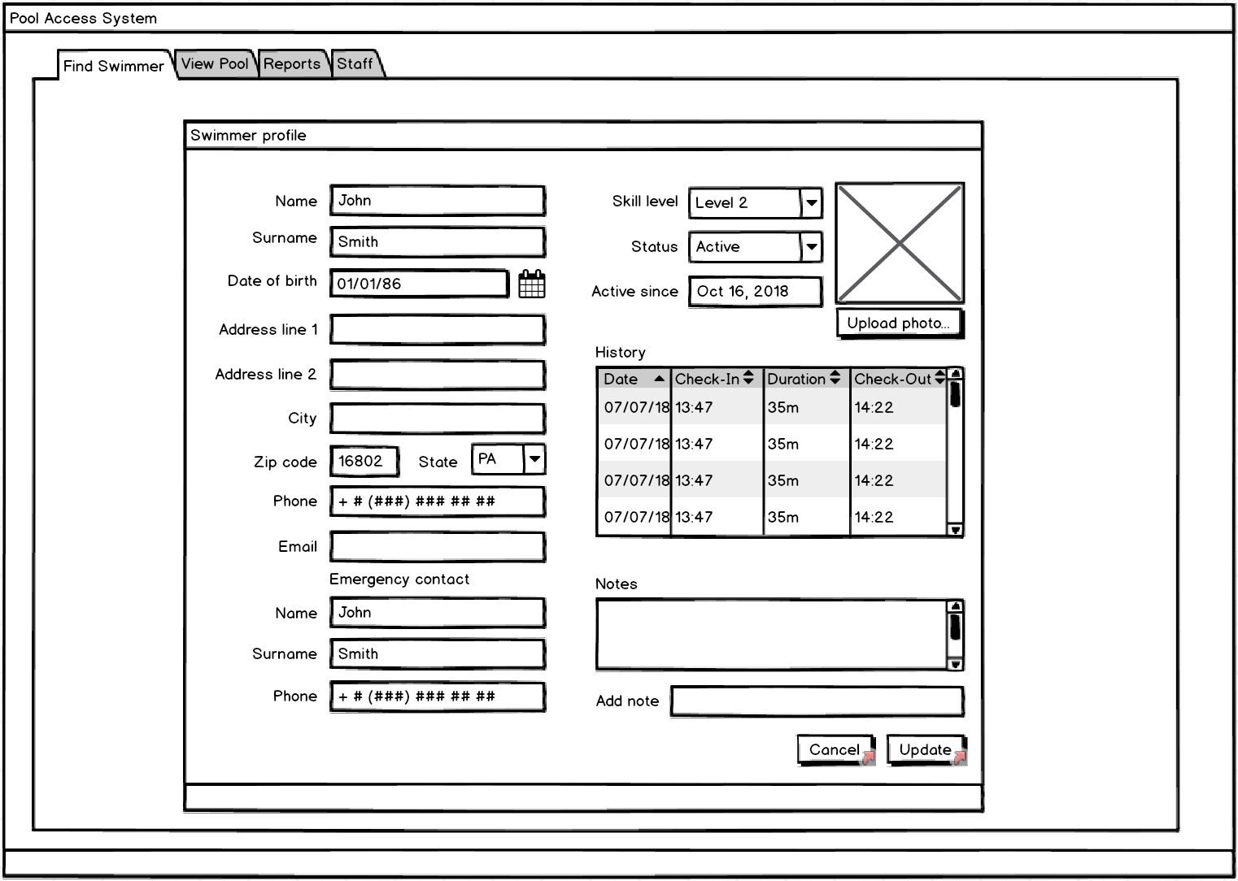

Similar to “Register New Swimmer”, “Swimmer Profile” allows the user to view and edit (if permitted) the specific swimmer’s information. This screen contains a “History” section, which enables the user to view that swimmer’s visit history, along with information such as check in and out, date of visit, and duration of visit.

* Upload photo
  + Opens the directory explorer for the user to select an appropriate file to attach to the swimmer’s profile.
* Update
  + The Update button is disabled by default, and is only enabled once there has been a change made to any field. If the user wants to edit the swimmer, this is where they do so.
* Navigate to another use case
  + Click on the tab on the top of the screen that corresponds to the desired use case

### View Pool screen:

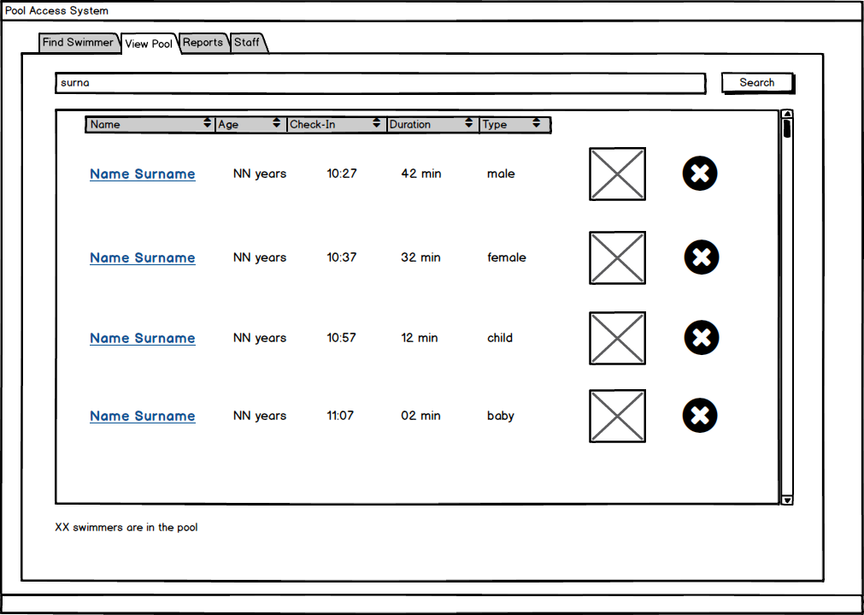

The View Pool Screen displays a list of swimmers currently checked in and active at the pool along with the swimmers’ age, check-in time, duration spent at the pool, type (male, female, child, baby), and picture. The list can be further refined by name or sorted. The user may access a swimmer’s full profile information or check swimmers out of the pool.

Instructions:

* Search by Name
  + Type a first or last name into the search field and click the search button. The screen will display matching results or an error message.
* Toggle order by Name, Age, Check-In Time, Duration at the Pool, or Type
  + Click the respective category in the title bar to sort the list accordingly, an additional click will reverse the order
* Check-out Swimmer
  + Click the ‘X’ on the row of the swimmer to be checked-out. The swimmer will be removed from the list.
* View a Swimmer Profile
  + Click the underlined name of the swimmer.
* Navigate to another use case
  + Click on the tab on the top of the screen that corresponds to the desired use case

### Reports/View Visits screen:

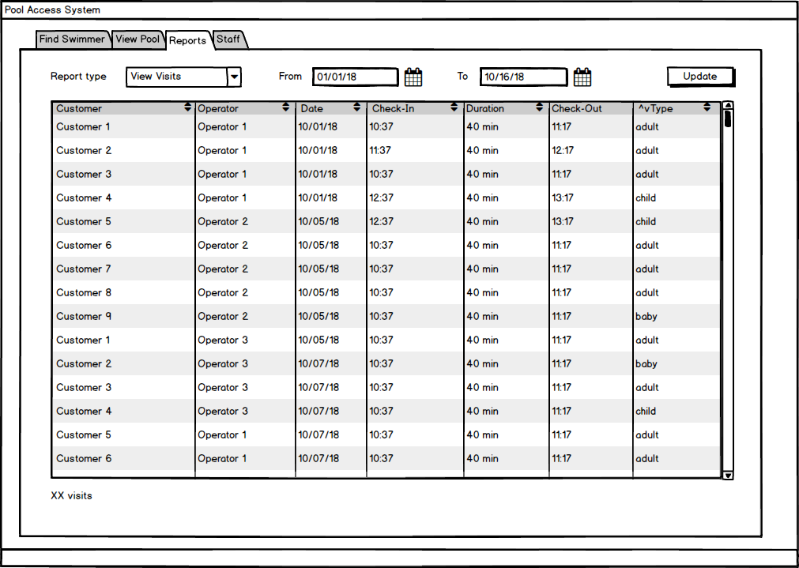

### Reports/View Customers screen:

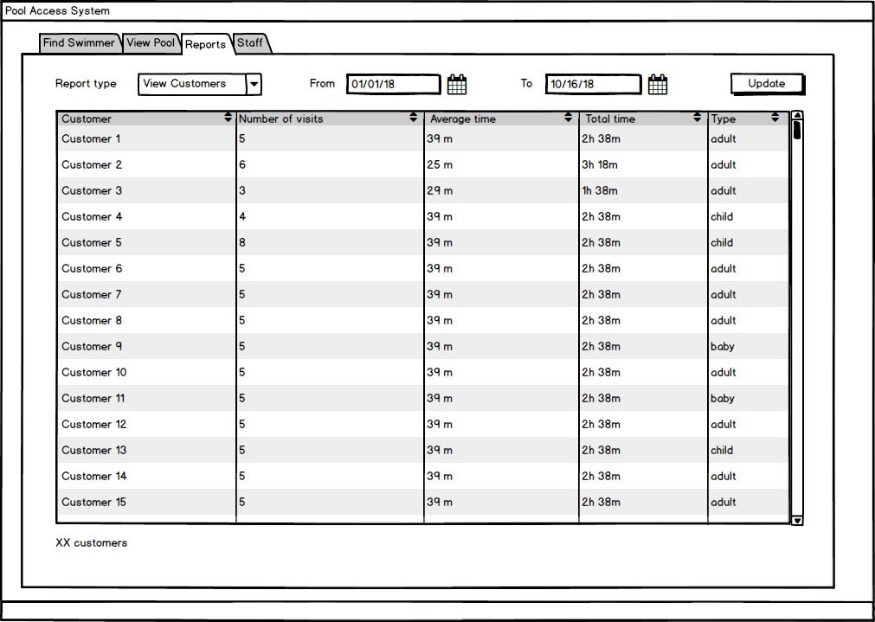

### Reports/Attendance screen:

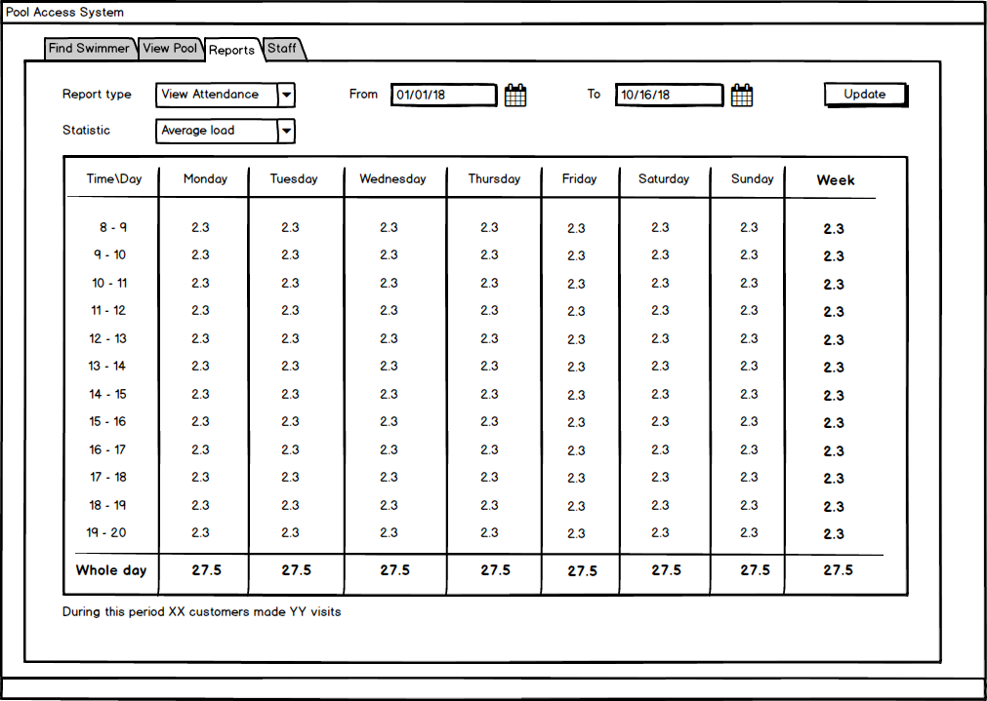

### Staff screen:

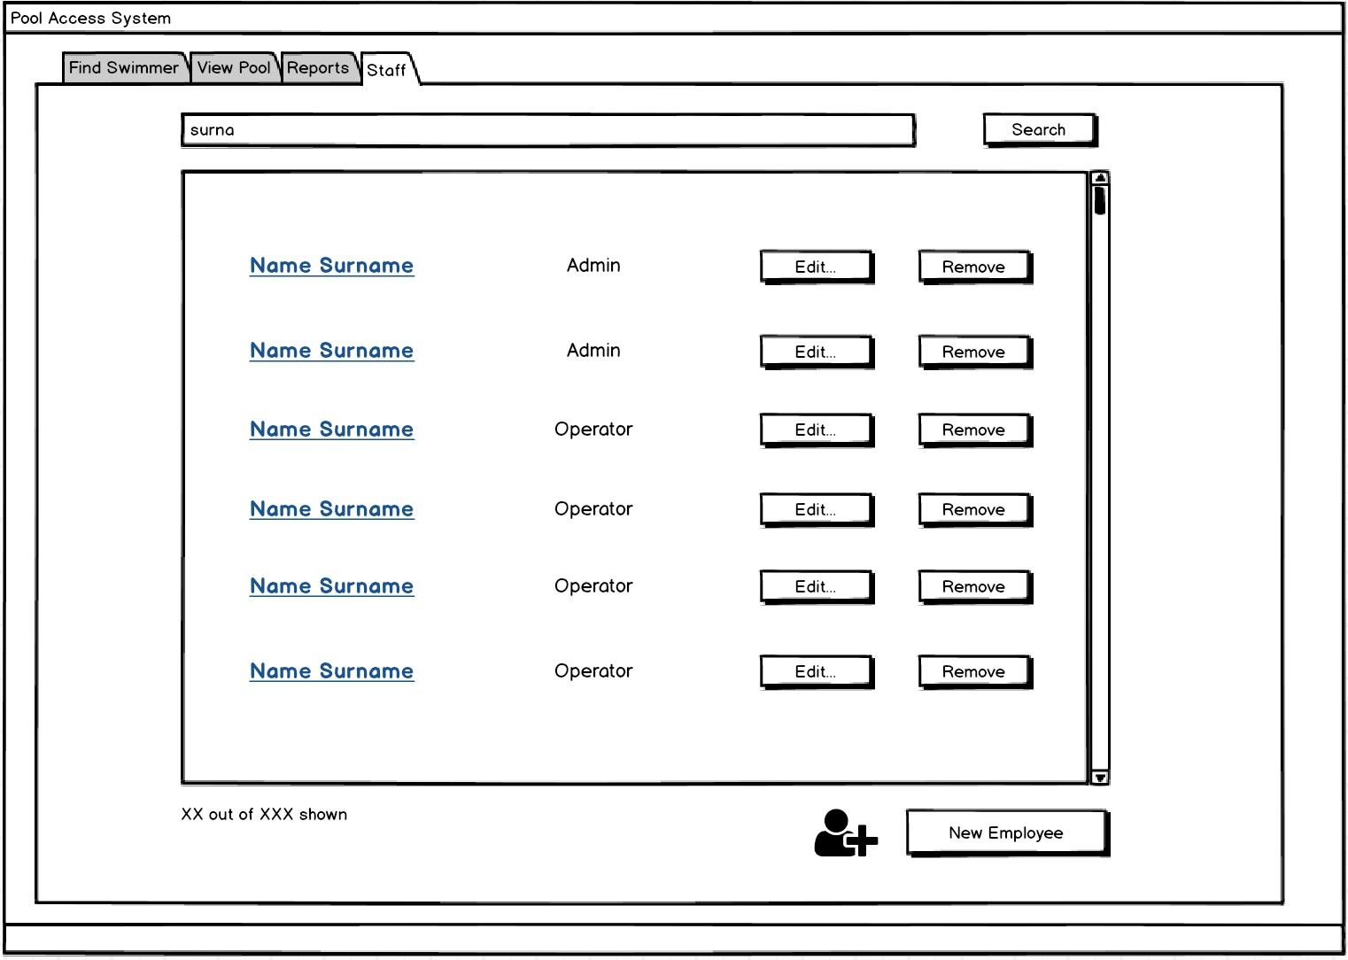

The Staff screen enables any-role user to search for an employee. This screen serves as a landing page for editing, removing, and creating new employees for Admin users. For Operator users, this is only a searchable page where they can see their and other employee’s role.

* Staff name hyperlink and Edit
  + The clickable staff’s name and Edit buttons are for Admins only, they will be disabled otherwise. Both of these buttons lead the user to the same Edit Employee screen. Any changes made in that screen are reflected when the user returns to this page.
* Remove
  + Clicking Remove prompts the Admin to verify the name of the employee they want to delete. This is to ensure they clicked on the correct employee. If the typed-in swimmer name matches the one they wish to remove, then that employee is removed from EmployeeList.
* New Employee
  + Clicking New Employee redirects the Admin user to the New Employee screen. After finishing with that screen, any new employees will be immediately present and searchable in this Staff list.
* Navigate to another use case
  + Click on the tab on the top of the screen that corresponds to the desired use case

### New Employee screen:

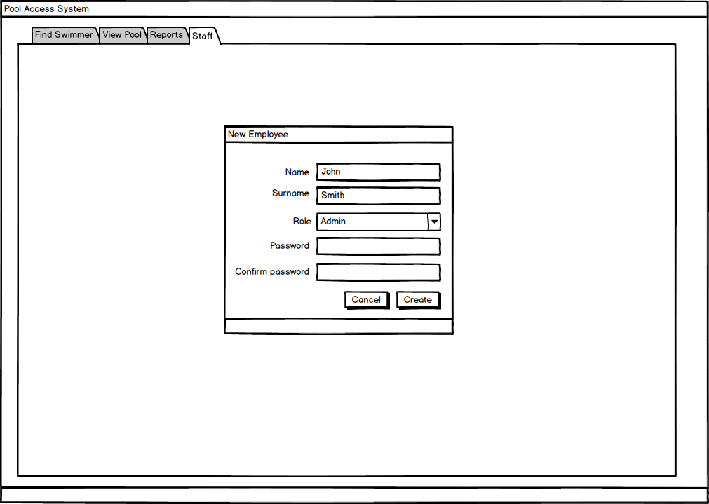

The “New Employee” screen allows any Admin users to create a new employee for the application. The Role dropdown signifies the Admin or Operator role that the user will have. This is editable later, but it determines what the newly created employee can and cannot do. The employee ID is automatically generated with the surname + first 2 characters of first name. The password is also entered on this screen and verified. Both of these make up the employee’s credential, which they can use to log in afterwards.

* Create
  + Clicking Create verifies that all fields are filled out appropriately, and if so then it saves the employee into the appropriate file to be accessed later.
* Navigate to another use case
  + Click on the tab on the top of the screen that corresponds to the desired use case. In this case, doing so without clicking Create will not save any changes.

### Edit Employee screen:

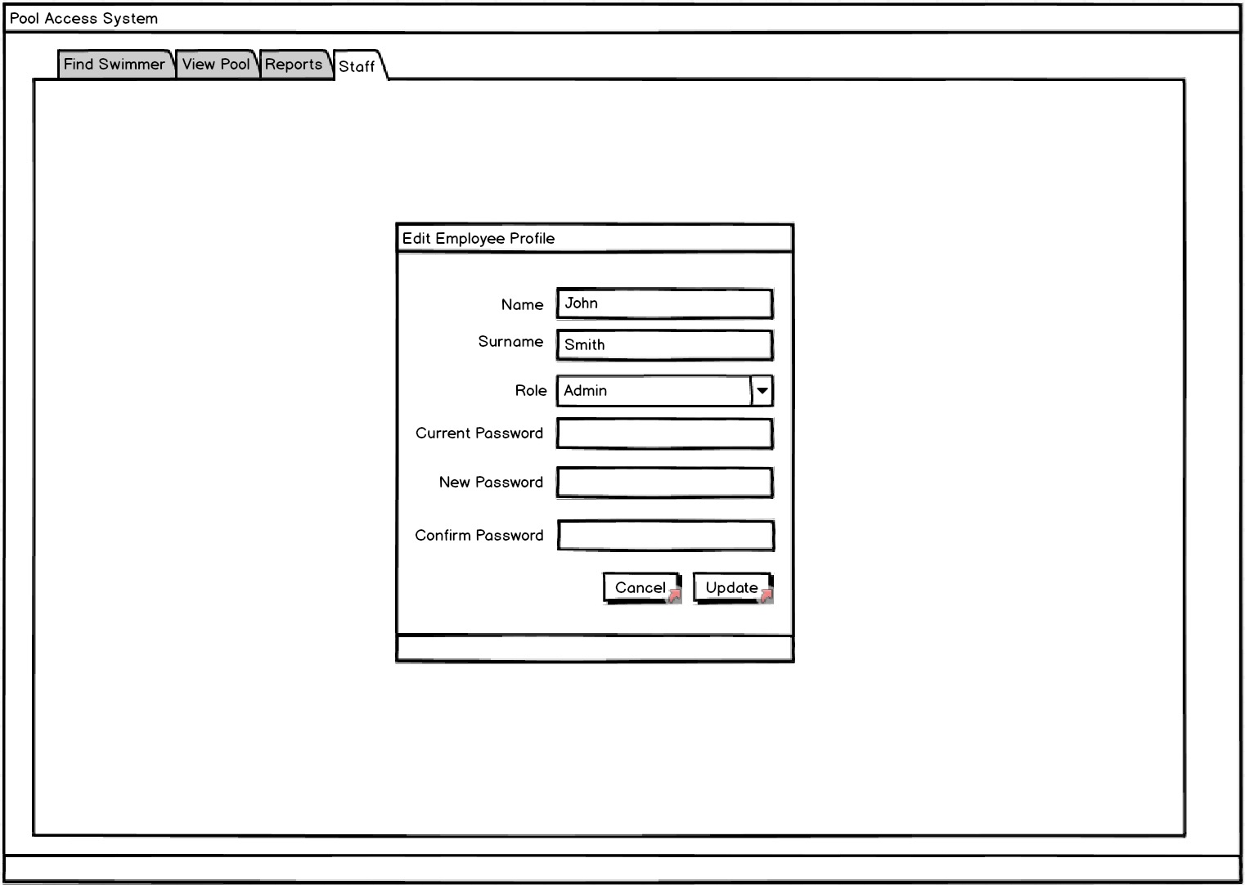

The Edit Employee screen allows any Admin users to edit any existing employee. The fields are mostly the same as the New Employee screen, with the exception of having the ability to change the user’s password.

* Update
  + Clicking Update verifies that all fields are filled out appropriately, and if so then t updates the specified Employee in the EmployeeList
* Cancel
  + Clicking Cancel clears out any changes and returns the user to the previous screen (Staff) ignoring any unsaved changes that were made.
* Navigate to another use case
  + Click on the tab on the top of the screen that corresponds to the desired use case. In this case, doing so without clicking Update will not save any changes made to that employee.